**Control Systems**

**Prof. C. S. Shankar Ram**

**Department of Engineering Design**

**Indian Institute of Technology, Madras**

**Lecture – 27**

**Special Cases of Routh’s Stability Criterion   
Part – 1**

Let us continue with our discussion on the Routh’s criteria. In the last class, we started off with the question as to how one could obtain the distribution of roots of a polynomial. We figured out that we can construct the Routh’s array and check the number of sign changes the first column of the Routh’s array. This can be used for control system design to check for what values of controller parameters the closed loop system would become stable. We form the Routh’s array for the closed loop characteristic polynomial and then figure out the feasible regions for the controller gains. Let us see a few examples to point out some special cases that may come up with the construction of the Routh’s array and then how to handle them.

(Refer Slide Time: 01:20)

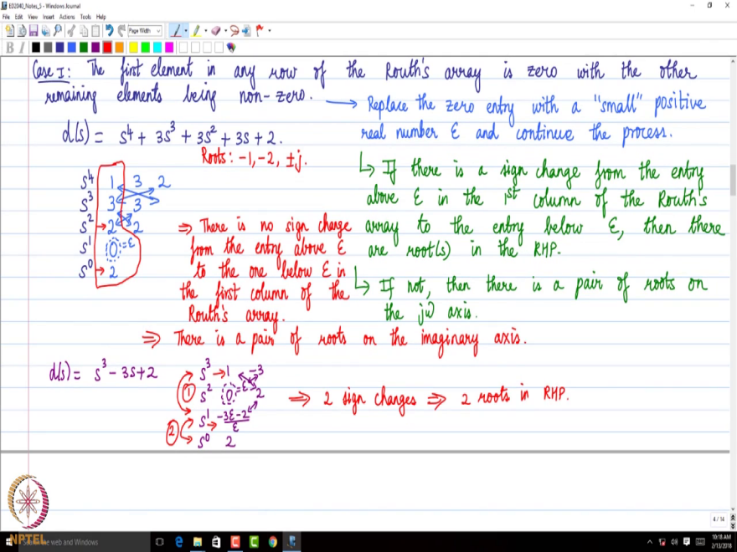

The first case is when the first element in any row of the Routh’s array is zero with the other remaining elements or entries being non-zero. Let us consider the polynomial,

${D\left(s\right)=s}^{4}+3s^{3}+3s^{2}+3s+2$

We can observe that all coefficients are non-zero and of the same sign. So the necessary condition is satisfied in this particular polynomial. Let us construct the Routh’s array.

If we want only to figure out the distribution of roots we can continue even when that necessary condition is not satisfied. That is the necessary condition for stability.

|  |  |  |  |
| --- | --- | --- | --- |
| $s^{4}$ | 1 | 3 | 2 |
| $s^{3}$ | 3 | 3 |  |
| $s^{2}$ | 2 | 2 |  |
| $s^{1}$ | 0 ( $ε)$ |  |  |
| $s^{0}$ | 2 |  |  |

We can see that the first entry in $s^{1}$ row is zero. Now we follow the procedure below. Replace the zero entry with a “small” positive real number $ε$ and continue the process. And from here, once we continue this process, if there is a sign change from the entry above epsilon in the 1st column of the Routh’s array to the entry below epsilon then there are roots in the RHP. For example, if the entry above epsilon is positive and the entry below epsilon is negative, then there are roots in the right half plane. If there is no sign change from the entry above epsilon to the entry below epsilon then there is a pair of roots on the $jω$ axis or the imaginary axis

Let us see what happens in the current example. We are going to replace the 0 with a small positive number positive real number $ε$ and continue the calculation. We get 2 in the $s^{0}$ row. If we look at the entry above epsilon and the entry below epsilon, we can observe that there is no sign change from the entry above epsilon to the one below epsilon in the first column of the Routh’s array. This implies that there is a pair of roots on the imaginary axis. If we calculate the roots of the polynomial, we get $-1,-2, ±j$. We can see that out of the 4 roots there are 2 roots on the $jω$ axis the remaining 2 roots are in the left half plane. Without solving for the roots, we can get the distribution of roots.

Let us do one more example;

$D\left(s\right)=s^{3}-3s+2$

We see that not all the coefficients are 0 and of the same sign, but find out the distribution of roots. Let us carry out the construction of the Routh’s array.

|  |  |  |  |
| --- | --- | --- | --- |
| $s^{3}$ | 1 | -3 |  |
| $s^{2}$ | 0 ( $ε)$ | 2 |  |
| $s^{1}$ | $\frac{-3ε-2}{2}$ |  |  |
| $s^{0}$ | 2 |  |  |

Now, if we look at the elements below and above epsilon, the element above epsilon has a positive sign and the element below epsilon has a negative sign. There is a sign change below and above epsilon. We need to count that as one sign change. Then from $s^{1}$ row to $s^{0}$ row in the first column, there is another sign change. So there are 2 sign changes. This implies that there are 2 roots in the right half plane with the remaining root in the left half plane. That is the conclusion we can draw here. The roots of the polynomial are $-2,1,1.$